Question 1

A Uniform Resource Locator (URL) is the address of a resource on the internet. For example, http://www.aqa.org.uk/qual/gce/computing_new.php.

Explain the different parts of this address.

http://:
www.aqa.org.uk:
/qual/gce/computing_new.php:

(3 marks)

Question 2
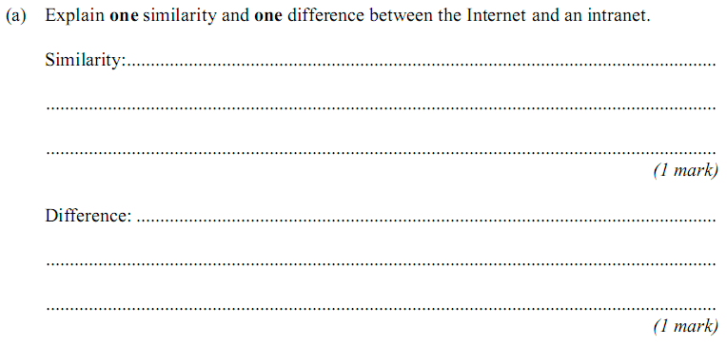
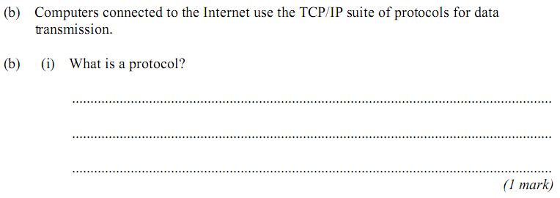

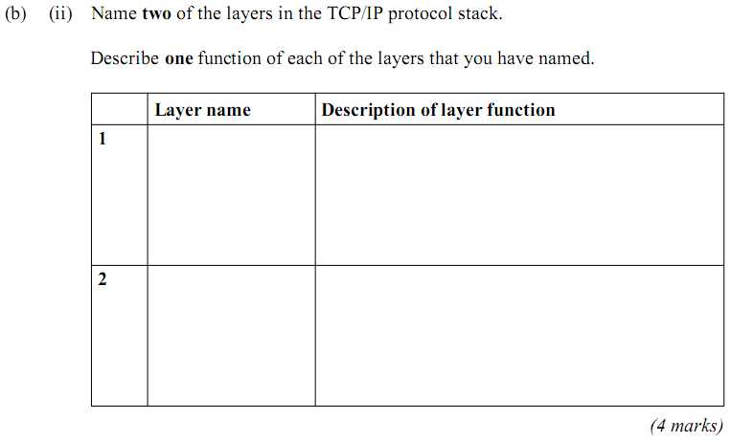
Question 3
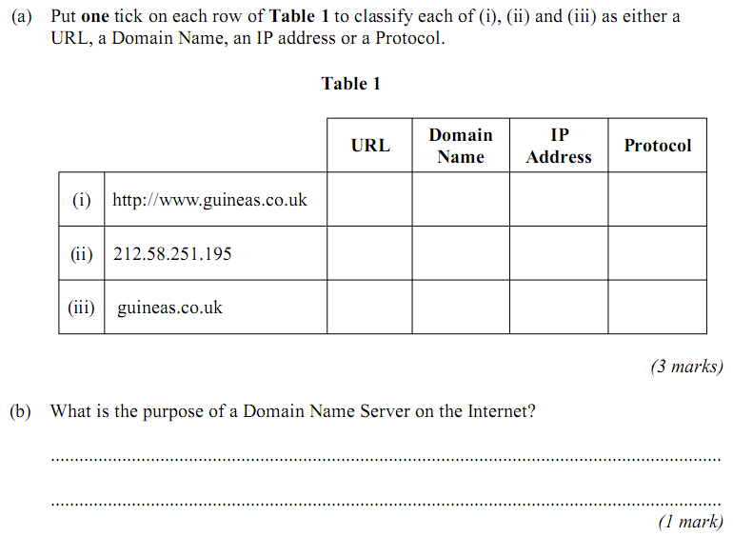

Question 4

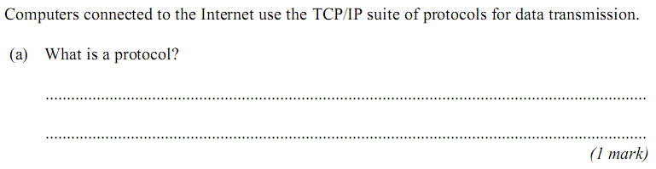
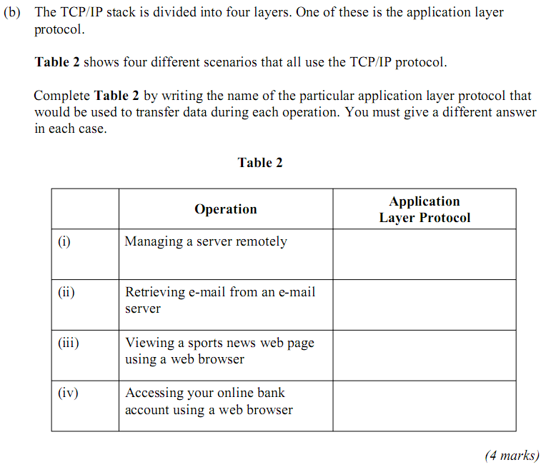

Question 5
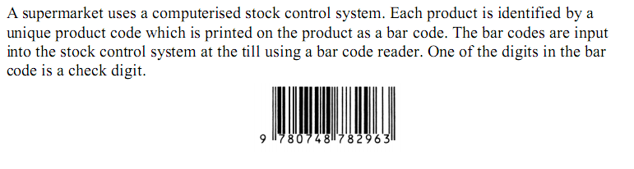
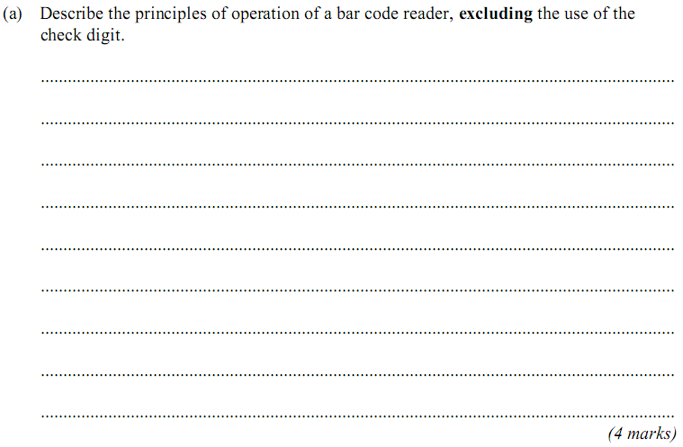
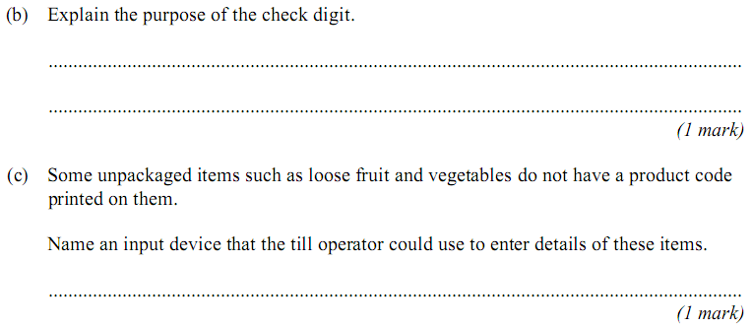

Total: 26 marks

